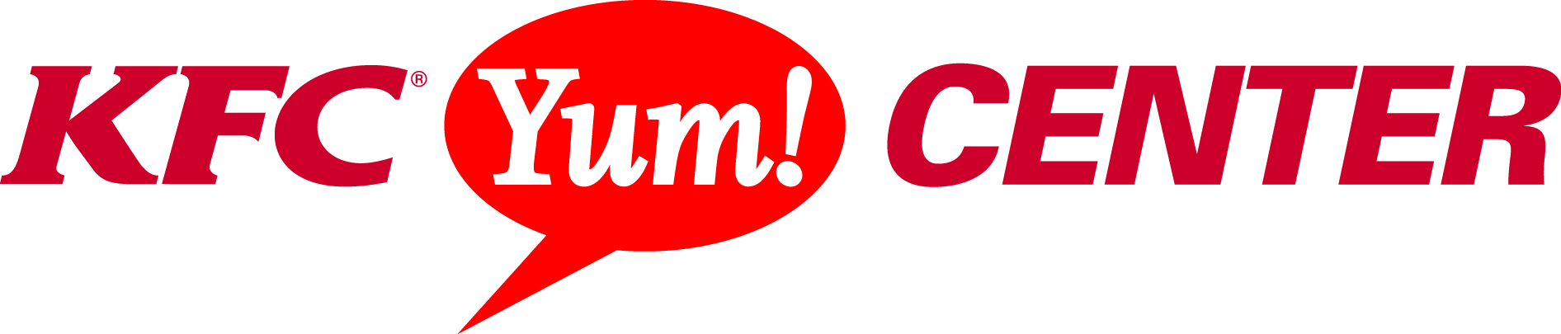

JIMMY BUFFETT & THE CORAL REEFER BAND BRING “SONGS FROM ST. SOMEWHERE TOUR 2013” TO LOUISVILLE NOVEMBER 30TH
Tickets on Sale Friday, September 27

Contact: Sandra Kendall Deanna Southerling
Marketing Manager Marketing Coordinator/Social Media Specialist
(502) 991-1546 (502) 690-9014

Louisville, Ky. (September 19, 2013) - Jimmy Buffett and the Coral Reefer Band return to KFC Yum! Center for a night of fin-tastic music and fun on Saturday, November 30 at 8:00 p.m. as part of Jimmy Buffett’s “Songs From St. Somewhere” Tour 2013. Tickets will go on sale next Friday, September 27th at 10 a.m.
Local Parrotheads won’t want to miss their chance to soak in the full Margaritaville experience.
“We are thrilled to welcome Jimmy Buffett back to KFC Yum! Center after his much talked about performance to a sold out crowd in 2012” said Dennis Petrullo, General Manager of the KFC Yum! Center, “Fans cannot wait for Buffett to bring Margaritaville back to Louisville!”
Jimmy recently released a new record, titled Songs From St. Somewhere, on Mailboat Records, which debuted at #4 on Billboard’s Top 200 albums the week of September 7th. The album, with 15 new songs plus a bonus track, was recorded this spring in various locales including Key West, Nashville, Miami, St. Barts and London. "Too Drunk To Karaoke", the first single, is a duet with Toby Keith and the video was shot in Nashville. Jimmy has been performing this song, as well as "I Want To Go Back To Cartagena", "Somethin' 'Bout A Boat" and "Oldest Surfer On The Beach" on the current tour.

# # #

The KFC Yum! Center is Louisville’s newest multi-purpose arena that boasts a total of 721,762 square feet while offering an arena bowl exceeding 22,000 seats and four meeting rooms spanning approximately 34,000 square feet all within walking distance of more than 4,200 hotel rooms in downtown Louisville. It is home to the University of Louisville men’s and women’s basketball programs and is ideal for concerts, conventions, corporate events, family shows, ice shows, wrestling and more. The KFC Yum! Center is a state of the art facility with advance technology capabilities that is owned by the Louisville Arena Authority and managed by AEG Worldwide. For more information, visit www.kfcyumcenter.com.
About AEG Facilities
AEG, a wholly owned subsidiary of the Anschutz Company, is the leading sports, entertainment and venue operator in the world. AEG Facilities, a stand-alone affiliate of AEG, owns, operates or consults with 100 of the industry’s preeminent venues worldwide, across five continents, and works in concert with affiliated AEG entities, including live event producer, AEG Live, AEG Global Partnerships and AEG Development to support the success of AEG venues across the globe. AEG owns, operates or provides services to venues including STAPLES Center (Los Angeles, Calif.), The Home Depot Center (Carson, Calif.), Nokia Theatre L.A. LIVE (Los Angeles, Calif.), Citizens Business Bank Arena (Ontario, Calif.), Valley View Casino Center (San Diego, Calif.) Sprint Center (Kansas City, Mo.), XL Center (Hartford, Conn.), The Rose Garden (Portland, Ore.), KeyArena (Seattle, Wash.), KFC YUM! Center (Louisville, Ky.), AmericanAirlines Arena (Miami, Fla.), AT&T Center (San Antonio, Texas), Time Warner Cable Arena (Charlotte, N.C.), Prudential Center (Newark, N.J.), Target Center (Minneapolis, Minn.), BBVA Compass Stadium (Houston, Texas), KFC Yum! Center (Louisville, Ky.), O.co Coliseum and Oracle Arena (Oakland, Calif.), Mercedes-Benz Arena (Shanghai, China), MasterCard Center (Beijing, China), The O2 Arena (London, England), O2 World (Berlin, Germany), O2 World Hamburg (Hamburg, Germany), Ahoy Arena (Rotterdam, Netherlands), Pernambuco Stadium (Recife, Brazil), Allphones Arena (Sydney, Australia), Ericsson Globe Arena (Stockholm, Sweden) and the Qatar National Convention Centre (Doha, Qatar). For more information, please visit www.aegworldwide.com.


