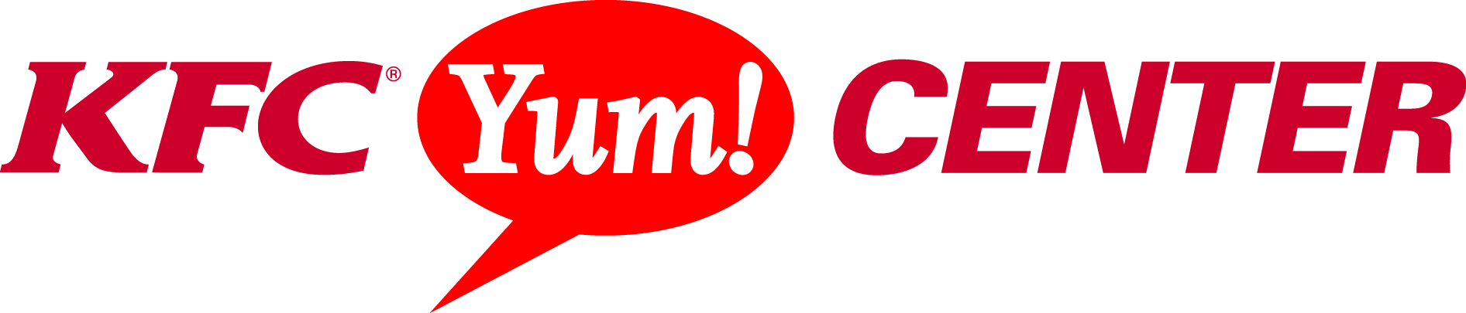

KATT WILLIAMS “KATT IS BACK TOUR” WILL COME TO LOUISVILLE NOVEMBER 23rd
Tickets on Sale Friday, August 30th

Contact: Sandra Kendall Deanna Southerling
Marketing Manager Marketing Coordinator/Social Media Specialist
(502) 991-1546 (502) 690-9014

Louisville, Ky. ( August 28, 2013) - Katt Williams is back in action and ready to take his comedy act to Louisville! The Katt Is Back Tour comes to the KFC Yum! Center on Saturday, November 23. Tickets are available starting Friday, August 30 at 10 a.m. at the KFC Yum! Center Box Office, all Ticketmaster outlets, Ticketmaster.com or charge by phone 800-745-3000.
After taking a step back from his career as a working comic and seriously considering permanent retirement, Katt Williams returns refocused and reborn as the comic genius that once took the comedy world by storm.
Beginning his career at an age when most teenagers are seeking their driver’s license, Katt Williams quickly discovered that he had a gift for making people laugh. In 1999, Williams became a presence at popular comedy clubs such as The Improv, The Comedy Club, The Icehouse and had his own room at The Hollywood Park Casino where he had a large, loyal following. He became a staple comedic force on the BET Network, appearing on shows such as Comic View, Rip the Runway, Black Carpet, Rap City, 106 & Park, The BET Awards and even hosting the first ever BET Hip Hop Awards in 2006. Katt Williams’ talent extends across multiple mediums. Williams is known to most for his breakout role in three seasons of Nick Cannon’s highly-rated MTV improv show, Wild n’ Out and his acting roles in Ice Cube’s Friday After Next and First Sunday. He has been featured in the parody films Epic Movie and Scary Movie V. His small screen appearances include NYPD Blue, UPN’s Girlfriends, The Tracy Morgan Show, Wanted, My Wife and Kids, Russell Simmon’s HBO Def Comedy Jam and as an animated character (A Pimp Named Slickback) on the popular adult cartoon The Boondocks. Throughout his career Williams has been embraced by the hip hop community, appearing in music videos for everyone from Outkast (“Roses”) and Ludacris (“Stand Up & “Number One Spot”) to E-40 (“One Night Stand”) and Lil’ Kim (“Shut Up/Lighter’s Up”).
Williams’ ability to make people laugh is best demonstrated on the stage as a stand-up comic. His hour-long specials include The Pimp Chronicles part 1 (2005), American Hustle (2007), Its Pimpin’ Pimpin’ (2008), and his most recent Showtime special Kattpacalypse (2012).

# # #
The KFC Yum! Center is Louisville’s newest multi-purpose arena that boasts a total of 721,762 square feet while offering an arena bowl exceeding 22,000 seats and four meeting rooms spanning approximately 34,000 square feet all within walking distance of more than 4,200 hotel rooms in downtown Louisville. It is home to the University of Louisville men’s and women’s basketball programs and is ideal for concerts, conventions, corporate events, family shows, ice shows, wrestling and more. The KFC Yum! Center is a state of the art facility with advance technology capabilities that is owned by the Louisville Arena Authority and managed by AEG Worldwide. For more information, visit www.kfcyumcenter.com.
About AEG Facilities
AEG, a wholly owned subsidiary of the Anschutz Company, is the leading sports, entertainment and venue operator in the world. AEG Facilities, a stand-alone affiliate of AEG, owns, operates or consults with 100 of the industry’s preeminent venues worldwide, across five continents, and works in concert with affiliated AEG entities, including live event producer, AEG Live, AEG Global Partnerships and AEG Development to support the success of AEG venues across the globe. AEG owns, operates or provides services to venues including STAPLES Center (Los Angeles, Calif.), The Home Depot Center (Carson, Calif.), Nokia Theatre L.A. LIVE (Los Angeles, Calif.), Citizens Business Bank Arena (Ontario, Calif.), Valley View Casino Center (San Diego, Calif.) Sprint Center (Kansas City, Mo.), XL Center (Hartford, Conn.), The Rose Garden (Portland, Ore.), KeyArena (Seattle, Wash.), KFC YUM! Center (Louisville, Ky.), AmericanAirlines Arena (Miami, Fla.), AT&T Center (San Antonio, Texas), Time Warner Cable Arena (Charlotte, N.C.), Prudential Center (Newark, N.J.), Target Center (Minneapolis, Minn.), BBVA Compass Stadium (Houston, Texas), KFC Yum! Center (Louisville, Ky.), O.co Coliseum and Oracle Arena (Oakland, Calif.), Mercedes-Benz Arena (Shanghai, China), MasterCard Center (Beijing, China), The O2 Arena (London, England), O2 World (Berlin, Germany), O2 World Hamburg (Hamburg, Germany), Ahoy Arena (Rotterdam, Netherlands), Pernambuco Stadium (Recife, Brazil), Allphones Arena (Sydney, Australia), Ericsson Globe Arena (Stockholm, Sweden) and the Qatar National Convention Centre (Doha, Qatar). For more information, please visit www.aegworldwide.com.
